**Topics**

* Upstream and Downstream jobs in jenkins
* Git Submodules
* Git Hooks
* Pull request-based workflow
* Branching Strategies
* Build and Deploy of some application
* Adding Security to pipelines
* Exercise

**Upstream and Downstream jobs in Jenkins**

* Upstream project refers to project that triggered the build of current project. Downstream refers to the project that will be triggered by current project
* This can be configured in
  + PostBuild Actions of Upstream
  + Build triggers of Current Project

Let’s configure B as Downstream of A  
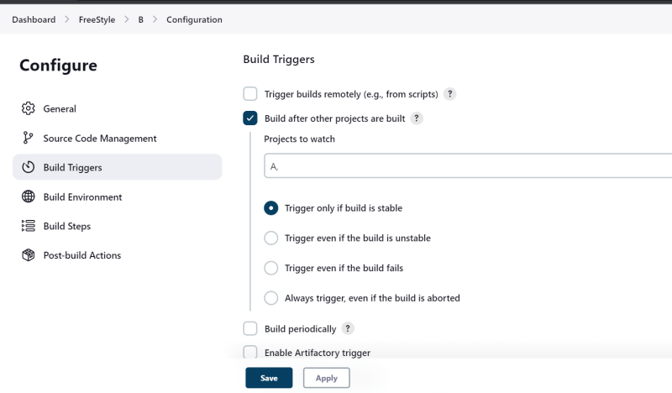  
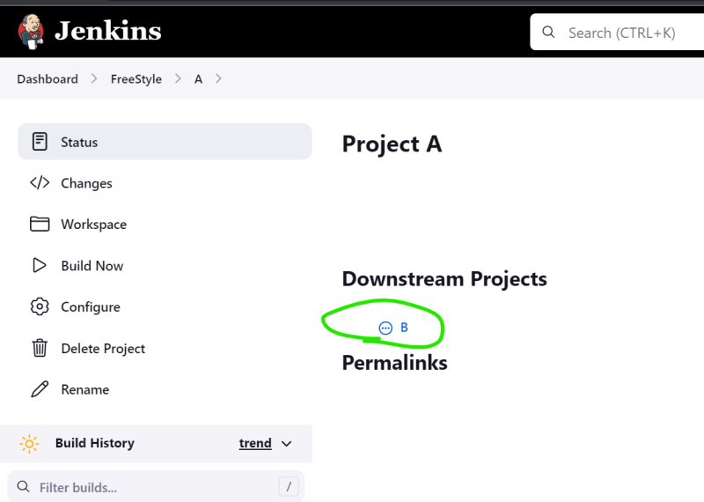

Lets configure C as Downstream of B  
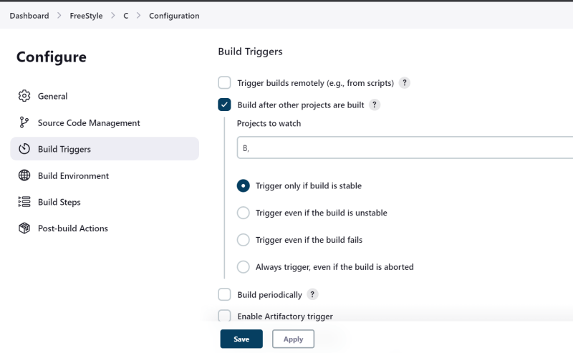  
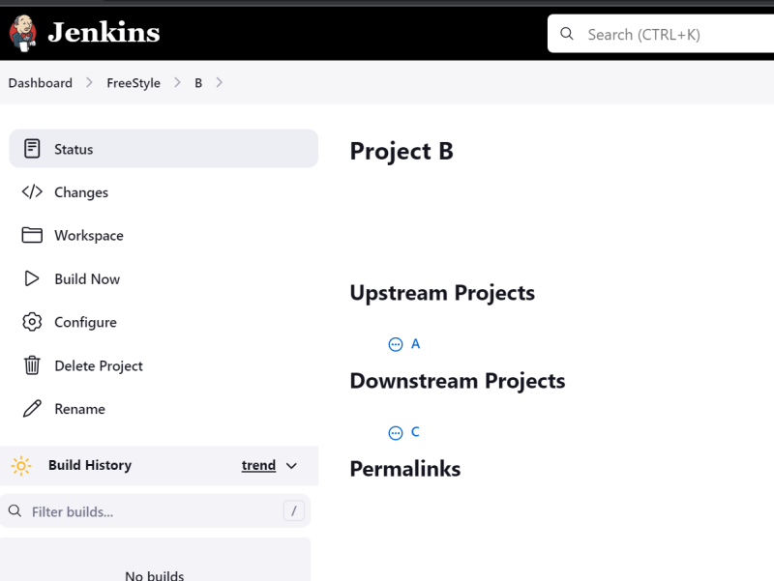  
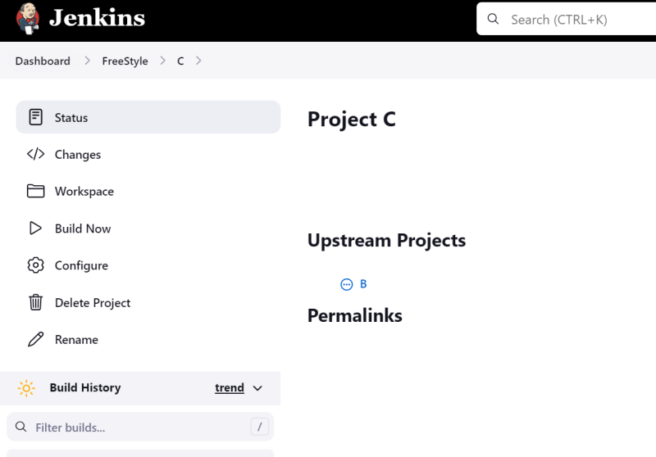

* Overview  
  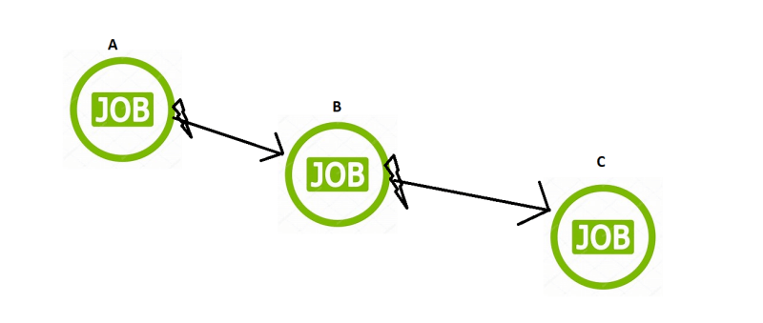
* Let’s Build A

**Git Submodules**

* Git Submodules allows us to use a repository within repository
* <https://www.atlassian.com/git/tutorials/git-submodule> for submodule
* <https://github.com/khajadevopsmarch23/cicdprojects> to this repository for submodules
* To push the changes in the submodules the push command git push origin HEAD:<branch>

**Git Alias**

* <https://www.atlassian.com/git/tutorials/git-alias> For Git Alias
* Git allows to create alias for existing commands.
* Alias are stored in config files

alias.pushsub=push origin HEAD:master

alias.rspush=push --recurse-submodules=check

alias.history=log --graph --decorate --pretty=oneline --abbrev-commit

alias.pushmain=push origin HEAD:main

alias.s=status

alias.pr=pull

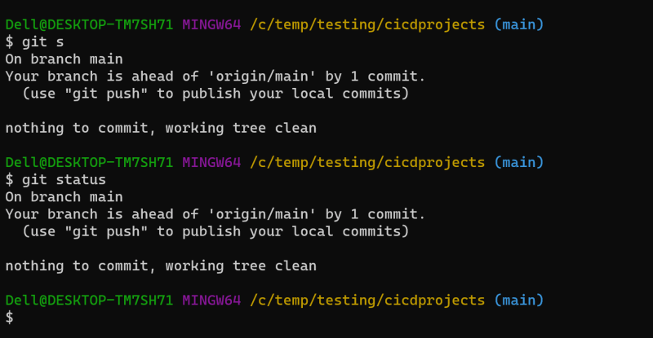

**Git Hooks**

* Hooks help us in adding custom behavior to Git
* To handle local events git has client-side hooks and to handle remote events git has server side hooks.
* <https://www.atlassian.com/git/tutorials/git-hooks> for git hooks  
  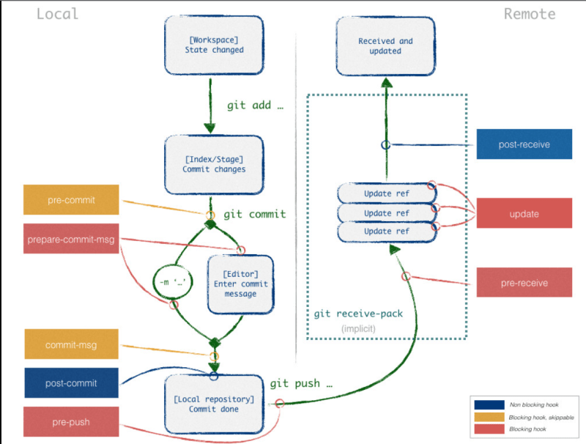
* In .git folder you have hooks folder  
  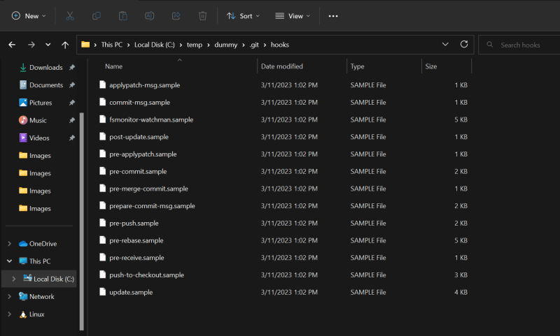
* <https://github.com/aitemr/awesome-git-hooks> for sample hooks repo
* For Remote repositories which are self-hosted, we can change the hooks
* For remote repo which is cloud hosted there we have to deal with access control for stopping users from pushing changes etc.
* If you need to call or perform any action when changes are received then they provide WebHooks.  
  